Bus Ticketing
System

NAME: Martin Paul F. Masiglat
COURSE CODE: IADIT
STUDENT ID: 0506-0908i8137
NAME OF LECTURER: Ms. Lorna Lim

Table of Contents
Introduction
Current System
Proposed System
Screen Design
Test Plan
Test Cases
Test Log
Implementation – User Manual
Source Code
Conclusion – Program Strength
Conclusion – Program Weakness
Conclusion – Program Enhancement

INTRODUCTION
The population Metro Manila is constantly increasing. Along with this increase comes additional traffic and congestion on surrounding roadways. There are numerous amounts of commuting students and employees are in rush, workers in the city and surrounding areas, and added construction and archeological projects. At peak points during the day many buses are greatly affected by traffics, and some buses lose their profits because of the bus ticket system that they are using. For example, the Casper bus liner, they use manual ticketing system which can easily confused the conductors and most passengers take advantage of it by cheating. Because of this, bus liners lose profit. And because of that, I recommend that they use Automatic Ticketing System that would accurately calculate their profit and make the conductors job much easier.

Current System
The Manual Ticketing Systems that they are using is that they have to buy tickets in bundles of one’s, two’s, five’s and ten’s which is equivalent to Philippine currency. The conductor should memorize the fare matrix in order for him to know the fare of each passenger depending on how far their destination is. Then conductor must make sure that each passenger gets a ticket and it’s paid for. With the continuous coming in of passengers, there are times that conductors usually get confused of the tickets they give to the passengers. That’s why bus liners hired inspectors to check whether the tickets that the conductors give are not recycled and is accurate based on the fare matrix.

Proposed System
The Automatic Ticketing System is automated fare calculating system that generates ticket in a form of a receipt. It will help the conductor do his job easily. With just entering the destination from where the passenger came from and to his desired destination, the system will automatically compute for the fare of the passenger, and the conductor will just have print it in order to generate a ticket. The system can also show the total profit they gain for that day. And with regards to the changing of fare matrix by the government, the management can also adjust the fare in the system to update it.

Screen Design
Cavite Bus Transit
[ Menu ]
[ 1.] Ticket Transaction

Choice:
Cavite Bus Transit
Ticket Transaction
Choose Destination [ 1 ] North [ 2 ] South
Route:

Cavite Bus Transit
Ticket Transaction
Choose Destination [ 1 ] North [ 2 ] South
Route: 1
From: To:
[1] [4]
[2] [5]
[3] [6]
Cavite Bus Transit
Ticket Transaction
Choose Destination [ 1 ] North [ 2 ] South
Route: 1
From: 1 To: 3
Fare Total: P 11.00 Kilometers: 2
[1] [4]
[2] [5]
[3] [6]

-------------------------
* Cavite Bus * [ Menu ]
* Transit *
* * [ 1 ] Print
* P11.00 * [ 2 ] Back to Menu
* *
* Ticket no. 1 * Choose:
* Thank you for *
Riding!!
Happy Trip!

Testing - Plan
Test Cases | Objectives
Case 1 | To check for the correct entry range of the options in the main menu.
Case 2 | To check for the correct entry of the options in the Ticket Transaction
Case 3 | To show the Destination if you press 1 or 2
Case 4 | To show the fare total and the total kilometers after picking the destination
Case 5 | To check that the number of characters entered for the passport number does not exceed 15.

Testing – Test cases

Test case : 1
Objectives : To check for the correct entry of the options in the main menu.
Test Data : Enter the number 2 to test.
Expected Test Result : If the number 2 is entered, the screen will display error message “INVALID INPUT!”
Actual Test Result : As below.
Conclusion : Succeeded. Error message was displayed when the test data was entered.

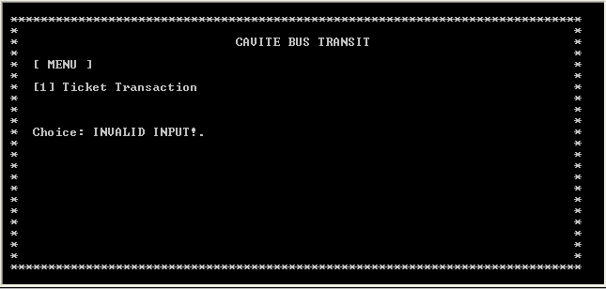

Test case : 2
Objectives : To check for the correct entry of the options in the Ticket Transaction
Test Data : Enter the number 3 to test.
Expected Test Result : If the number 3 is entered, the screen will display error message “INVALID INPUT!” and will go back to main menu.
Actual Test Result : As below.
Conclusion : Succeeded. Error message was displayed when the test data was entered.

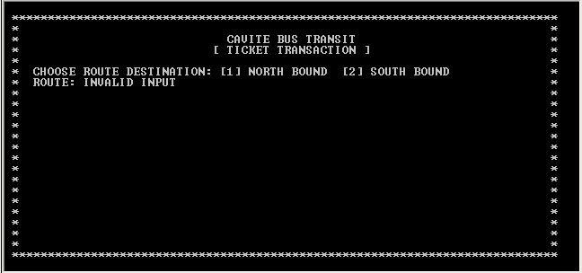

Test case : 3
Objectives : To show the Destination if you press 1 or 2
Test Data : Enter the number 1 to test.
Expected Test Result : If the number 1 is entered, the screen will Display the destinations
Actual Result : As below.
Conclusion : Succeeded. The destinations appeared.

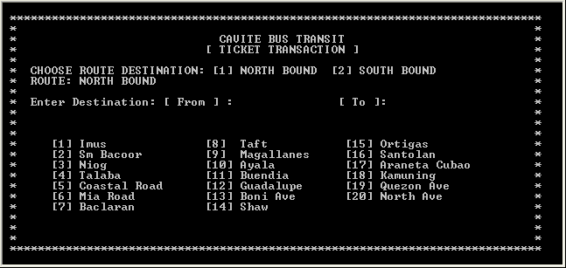

Test case : 4
Objectives : To show the fare total and the total kilometers after picking the destination
Test Data : Press Enter After picking the Destination
Expected Test Result : The Fare Total and Total Kilometers Will show
Actual Result : Shown Below
Conclusion : Succeeded, The fare total and the total kilometers appeared.

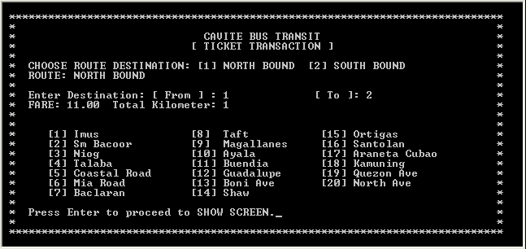

Test case : 5
Objectives : To check for the correct entry of the options in the Ticket Menu.
Test Data : Enter the number 3 to test.
Expected Test Result : If the number 3 is entered, the screen will display error message “INVALID INPUT!” and will go back to main menu.
Actual Test Result : As below.
Conclusion : Succeeded. Error message was displayed when the test data was entered.

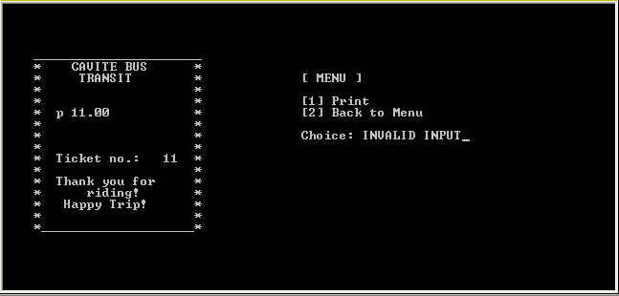

TESTING – TEST LOG
Test Cases | Status
Case 1 | Successful
Case 2 | Successful
Case 3 | Successful
Case 4 | Successful
Case 5 | Successful

Implementation – User Manual

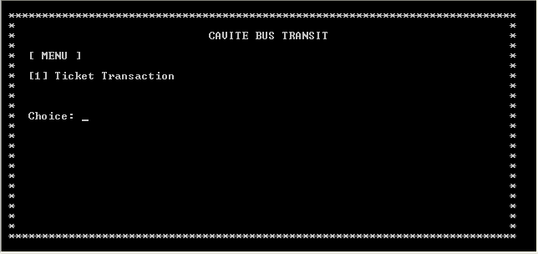
In Main menu, the ticket transaction menu is shown, press “ 1 “ to go to the ticket transaction menu.

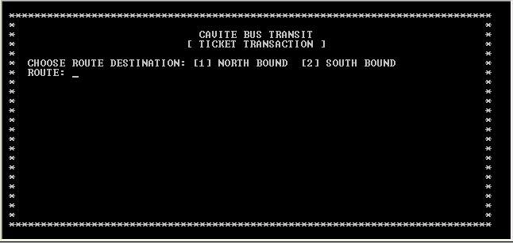
After pressing “ 1 “, this chart will show, as you can see, there is 2 choices, the [1] North Bound and the [2] South bound. Press 1 if going to north bound and press 2 if going to south bound.

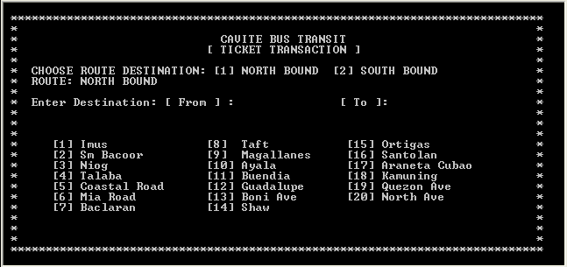

If you press 1, this chart will show, as you can see the route says “NORTH BOUND”, and you can also see the destinations from south bound going to north bound. Enter the destination where you from to the destination your going to then press enter.

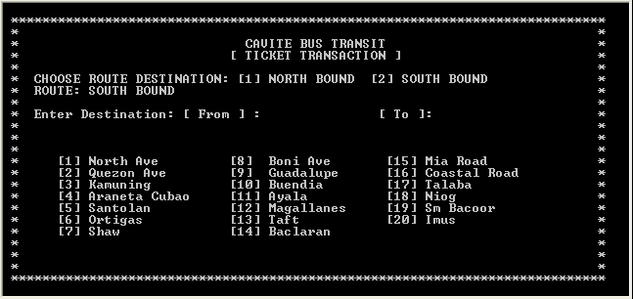

If you press 2, this chart will show, it is the same as the 1st chart. The difference is the route, now its south bound going to north bound.

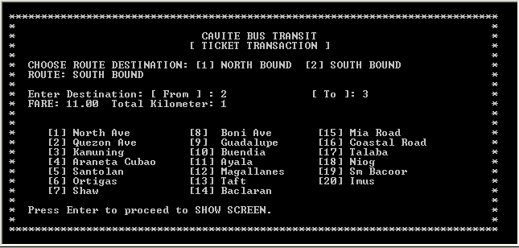
After entering the desired destination, the total amount will show and the Total kilometers reached. After that press “ Enter “.

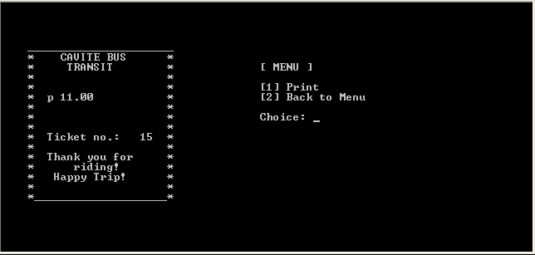
By pressing the “Enter” key, this chart will show, the receipt menu, there are 2 choices here, the [1] Print and [2] Back to Menu button.

Source Code
#include<stdio.h>
#include<stdlib.h>
#include<conio.h>

#define g gotoxy
#define p printf
#define s scanf

int i,x,dest,fr,to,rate,y,shch;
int place[20];
float fare;
double tick;

design()
{
for(i=0;i<=75;i++) { g(2+i,2); p("*"); }
for(i=0;i<=20;i++) { g(2,3+i); p("* \n"); }
for(i=0;i<=20;i++) { g(77,3+i);p("* \n"); }
for(i=0;i<=75;i++) { g(2+i,24);p("*"); }

g(32,4);p("CAVITE BUS TRANSIT");
}

menu()
{
clrscr();design();
g(5,6);p("[ MENU ]");
g(5,8);p("[1] Ticket Transaction");
g(5,12);p("Choice:");
g(13,12);s("%d",&x);
if (x == 1) ticket();
else if (x == 2);
else {
g(13,12);p("INVALID CHOICE!PRESS ENTER TO CHOOSE ANOTHER SELECTION.");
getch();menu();
}
}

ticket()
{ clrscr();design();
g(30,5);p("[ TICKET TRANSACTION ]");
g(5,7);p("CHOOSE ROUTE DESTINATION: [1] NORTH BOUND [2] SOUTH BOUND");
g(5,8);p("ROUTE:");g(12,8);s("%d",&dest);ticketop();
}

ticketdest()
{
g(5,10);p("Enter Destination: [ From ] : [ To ]: ");
g(35,10);s("%d",&fr);g(57,10);s("%d",&to);
if(to > fr)
{ destination();
g(5,11);p("FARE: %2.2f",fare);g(18,11);p("Total Kilometer: %d",y);
g(5,22);p("Press Enter to proceed to SHOW SCREEN.");getch();
}
if(to < fr)
{ ticketdest(); }
}
ticketop()
{
if(dest == 1) { g(12,8);p("NORTH BOUND");north();ticketdest();show(); }
else if(dest == 2) { g(12,8);p("SOUTH BOUND");south();ticketdest();show(); }
else ticket();
}

show()
{
clrscr();
tick = tick+1;
for(i=0;i<22;i++) { g(5+i,5); p("_"); }
for(i=0;i<22;i++) { g(5+i,20);p("_"); }
for(i=0;i<15;i++) { g(5,6+i); p("*"); }
for(i=0;i<15;i++) { g(26,6+i);p("*"); }
g(10,6);p("CAVITE BUS");
g(11,7);p("TRANSIT");

g(8,10);p("p %2.2f",fare);
g(8,14);p("Ticket no.: %4.0f",tick);

g(8,16);p("Thank you for ");g(12,17);p("riding!"); g(9,18);p("Happy Trip!");

if(dest == 1) { g(9,8);p("NORTH BOUND"); }
if(dest == 2) { g(9,8);p("SOUTH BOUND"); }

g(40,7);p("[ MENU ]");
g(40,9);p("[1] Print");
g(40,10);p("[2] Back to Menu");
g(40,12);p("Choice:");g(48,12);s("%d",&shch);
if(shch == 1) { print(); }
if(shch == 2) { menu(); }
}

print()
{ }

destination()
{
place[1]=0; place[9]=8; place[17]=16;
place[2]=1; place[10]=9; place[18]=17;
place[3]=2; place[11]=10; place[19]=18;
place[4]=3; place[12]=11; place[20]=19;
place[5]=4; place[13]=12;
place[6]=5; place[14]=13;
place[7]=6; place[15]=14;
place[8]=7; place[16]=15;

y=(to-fr);
if (y<=3) { fare = 11.00; }
if (y>=3) { fare = ((y-3)*2.50)+11.00; }

}

north()
{

g(29,10);p("NORTH BOUND");
g(8,14);p("[1] Imus"); g(30,14);p("[8] Taft"); g(50,14);p("[15] Ortigas");
g(8,15);p("[2] Sm Bacoor"); g(30,15);p("[9] Magallanes"); g(50,15);p("[16] Santolan");
g(8,16);p("[3] Niog"); g(30,16);p("[10] Ayala"); g(50,16);p("[17] Araneta Cubao");
g(8,17);p("[4] Talaba"); g(30,17);p("[11] Buendia"); g(50,17);p("[18] Kamuning");
g(8,18);p("[5] Coastal Road"); g(30,18);p("[12] Guadalupe"); g(50,18);p("[19] Quezon Ave");
g(8,19);p("[6] Mia Road"); g(30,19);p("[13] Boni Ave"); g(50,19);p("[20] North Ave");
g(8,20);p("[7] Baclaran"); g(30,20);p("[14] Shaw");

}

south()
{
g(29,10);p("SOUTH BOUND");
g(8,14);p("[1] North Ave"); g(30,14);p("[8] Boni Ave"); g(50,14);p("[15] Mia Road");
g(8,15);p("[2] Quezon Ave"); g(30,15);p("[9] Guadalupe"); g(50,15);p("[16] Coastal Road");
g(8,16);p("[3] Kamuning"); g(30,16);p("[10] Buendia"); g(50,16);p("[17] Talaba");
g(8,17);p("[4] Araneta Cubao"); g(30,17);p("[11] Ayala"); g(50,17);p("[18] Niog");
g(8,18);p("[5] Santolan"); g(30,18);p("[12] Magallanes"); g(50,18);p("[19] Sm Bacoor");
g(8,19);p("[6] Ortigas"); g(30,19);p("[13] Taft"); g(50,19);p("[20] Imus");
g(8,20);p("[7] Shaw"); g(30,20);p("[14] Baclaran");
}
main()
{
clrscr();
tick=00010;
menu();

getch();
return 0;
}

Conclusion – Program Strengths
For my conclusion, I would like to pass some comments about my program. Basically, my program My system is all about bus ticketing it can compute the fare of a customer based on the kilometers he/she consumed. Every kilometer has a fix rate of P 11.00, now every additional kilometer has a fixed rate of P 2.50 per Km.

Conclusion – Program Weakness
My programs weakness is that it can only compute the kilometers consumed, there is no fare adjustment and no net sales,

Conclusion – Program Enhancements
In the near future, some enhancements can be made to the program. A fare adjustment can be added to the program so that the user can change it in case there’s a change in the minimum fare.

